Chapter 4

CHAPTER 4. RESULTS AND ANALYSIS

This chapter presents the analysis and interpretation of the data gathered during the study, focusing on the system development, testing, and evaluation of PCOSina. All collected survey data were tested for reliability using Cronbach’s Alpha to ensure the consistency and accuracy of the research instrument, while all system outputs, computed statistics, and survey results were reviewed and validated by a statistician for accuracy. The contents of this chapter are organized based on the Statement of the Problem (SOP) of the study, and each SOP is directly addressed using results from system testing, user evaluation involving primary and secondary users, and supporting related literature. The application was also evaluated using the ISO/IEC 25010 software quality model, covering functional suitability, performance efficiency, compatibility, usability, reliability, security, maintainability, and portability, with additional input from IT/CS and healthcare experts.

Overall, this chapter primarily focuses on answering the Statement of the Problem of the study by presenting and analyzing all relevant findings. PCOSina is designed as a wellness decision-support tool and does not diagnose PCOS, prescribe treatment, or replace professional medical advice.

Evaluation Instrument Reliability Analysis

Cronbach’s Alpha
Cronbach's alpha is a measure of how well the items in a scale measure the same underlying construct (Cronbach, 1951). A high Cronbach's alpha indicates that the items on the scale are measuring the same underlying construct, and that the scores on the scale are consistent (Tavakol & Dennick, 2011). In this study, Cronbach's alpha was calculated for each of the software quality subscales across the separate surveys deployed for both the primary and secondary users to check the internal consistency of the pilot-tested survey instrument. This ensures that the questionnaire items under each software quality subscale are reliable for formal data collection.

The following table shows the Cronbach's alphas for the overall survey instruments and for each individual software quality subscale:

Table 25. Cronbach’s Alpha Results for Primary and Secondary User Surveys
Evaluation Subscale (Category) | No. of Items | Primary Users Alpha (α) | Remarks (Primary) | Secondary Users Alpha (α) | Remarks (Secondary)
Functional Suitability | 5 | 0.852 | Good | 0.922 | Excellent
Performance Efficiency | 5 | 0.792 | Acceptable | 0.893 | Good
Compatibility | 5 | 0.914 | Excellent | 0.813 | Good
Usability | 5 | 0.803 | Good | 0.845 | Good
Reliability | 5 | 0.897 | Good | 0.774 | Acceptable
Security | 5 | 0.874 | Good | 0.845 | Good
Maintainability | 5 | 0.962 | Excellent | 0.770 | Acceptable
Portability | 5 | 0.802 | Good | 0.834 | Good

An analysis of the Cronbach’s alpha coefficients for the eight ISO/IEC 25010 software quality subscales indicates strong internal consistency across all evaluation metrics for both survey instruments. For the primary user group, the reliability scores range from a low of 0.792 for Performance Efficiency to a high of 0.962 for Maintainability. Feedback collected from the secondary user group shows a similar distribution, with coefficients stretching from 0.770 for Maintainability up to 0.922 for Functional Suitability. These statistical indicators confirm that the survey questionnaires serve as stable and dependable tools for evaluating the software quality of PCOSina. Given that every single subscale successfully exceeded the standard psychometric baseline threshold of 0.700, the dataset gathered from both respondent pools is verified as internally consistent.

Summary of ISO/IEC 25010 Product Quality Evaluation
An evaluation of the software was performed through the use of survey forms based on the ISO/IEC 25010 standards. Before letting the respondents answer the survey forms, the purpose of the application was explained to them and they were given a user manual showing how the mobile application works. The survey forms consisted of five questions for each of the eight categories: Functional Suitability, Performance Efficiency, Compatibility, Usability, Reliability, Security, Maintainability, and Portability, with a total of 40 questions. The results were calculated using Likert scale equations, where 1 means strongly disagree and 5 means strongly agree to compute the weighted means. Table 22 consolidates the comparative assessments provided by the primary and secondary users across all 8 quality characteristics.

Table 26. Summary of ISO/IEC 25010 Evaluation Results for PCOSina
Category | Primary User Average Mean | Secondary User Average Mean | Overall Mean | Verbal Interpretation
Functional Suitability | 3.98 | 3.80 | 3.89 | Agree
Performance Efficiency | 3.94 | 4.01 | 3.98 | Agree
Compatibility | 4.22 | 4.05 | 4.14 | Agree
Usability | 3.98 | 4.18 | 4.08 | Agree
Reliability | 3.79 | 4.30 | 4.04 | Agree
Security | 4.02 | 4.18 | 4.10 | Agree
Maintainability | 4.21 | 3.62 | 3.91 | Agree
Portability | 4.10 | 4.10 | 4.10 | Agree
OVERALL TOTAL | 4.03 | 4.01 | 4.02 | Agree

The evaluation results show that both primary and secondary user groups gave positive evaluations of the application, with an overall total mean of 4.02 interpreted as “Agree.” Primary and secondary user means remain within close proximity, indicating that the application meets acceptable software engineering benchmarks under user-centered validation. The findings per category are analyzed sequentially below.
- Functional Suitability was evaluated positively with an overall mean of 3.89, derived from a score of 3.98 for primary users and 3.80 for secondary users. This indicates that the system is capable of integrating localized culinary elements, custom preferences, condition-appropriate dietary options, and pantry item arrays within its functional execution environment.
- Performance Efficiency was evaluated positively with an overall mean of 3.98, derived from a score of 3.94 for primary users and 4.01 for secondary users. This indicates acceptable system stability and response speeds during interactive runtime operations. Open-ended feedback noted minor processing delays during intensive operational routines such as full data matrix generation, which presents distinct paths for codebase efficiency optimization.
- Compatibility was evaluated positively with an overall mean of 4.14, derived from a score of 4.22 for primary users and 4.05 for secondary users. This indicates that the software infrastructure operates properly across target operating system conditions and functional states in both online and offline application environments.
- Usability was evaluated positively with an overall mean of 4.08, derived from a score of 3.98 for primary users and 4.18 for secondary users. This indicates that the interface structures, functional workflows, application layouts, and user instructions are accessible and comprehensible for both first-time and non-technical user cohorts.
- Reliability was evaluated positively with an overall mean of 4.04, with secondary users giving a higher average rating of 4.30 compared to primary users who gave a rating of 3.79. This indicates that the software configuration maintains functional operational persistence, data integrity during application state changes, and stability without experiencing frequent runtime faults or unexpected terminations.
- Security was evaluated positively with an overall mean of 4.10, derived from a score of 4.02 for primary users and 4.18 for secondary users. This indicates that users maintain confidence in the system's underlying data boundaries, account authorization structures, and personal information privacy measures during baseline transaction operations.
- Maintainability was evaluated positively with an overall mean of 3.91, with primary users giving a higher average rating of 4.21 compared to secondary users who gave a rating of 3.62. This indicates that the structural model architecture is capable of supporting iterative software upgrades, logical modifications, and secondary feature expansions highlighted within the open-ended user feedback logs.
- Portability was evaluated positively with both user groups obtaining identical average ratings of 4.10, resulting in a total average of 4.10. This indicates consistent multi-device configuration scalability, smooth installer execution, and visual adaptability across varying hardware display aspect ratios and local deployment device contexts.

In conclusion, the evaluation results indicate that PCOSina meets the software quality criteria defined in the ISO/IEC 25010 model, particularly in terms of functional suitability, usability, performance efficiency, reliability, security, maintainability, and portability. User feedback and expert evaluation suggest that the application is usable for generating meal plans and supports basic practical needs in meal planning. The system was assessed strictly as a wellness decision support tool and was not evaluated for medical, diagnostic, or treatment purposes.

Presentation and Analysis of Results Based on the Statement of the Problem

SOP 1: How can a weekly meal-planning system be designed to generate nutritionally adequate meal plans for Filipinos with PCOS while considering weight-management goals and dietary constraints?
PCOSina addressed this problem by implementing a modular, two-stage mathematical optimization pipeline that combines deterministic filtering, pantry-aware candidate construction, and constrained linear optimization as modeled in Figure 12. The system models weekly planning as a constrained scheduling problem in which recipes are assigned across breakfast, lunch, and dinner meal slots over a seven-day planning horizon. The overall system operational flow, from structural profiling input to the final expert-validated output layout, is illustrated in Figure 12, while the adaptive fallback mechanism used during highly conflicting or infeasible planning conditions is modeled in Figure 13.

The planning process starts with the user profile because PCOSina must convert personal, practical, and clinical user characteristics into structured, solver-ready values before it can generate a baseline meal plan. The profile captures thirteen distinct entry variables: age, height, weight, activity level, weight-management goal, dietary restrictions, allergies, explicit ingredient exclusions, preferred food behavior, weekly budget, cooking-time preference, variety preference, and pantry entries. These variables are not used for diagnostic purposes; they serve strictly as quantitative planning inputs that enable the system to compute precise baseline nutritional targets, filter out unsafe recipe nodes, and assemble a mathematically feasible weekly timeline.

The application normalizes free-form text inputs and categorical choices before initiation. Allergy names, restricted ingredients, exclusion terms, and pantry items are converted into tokenized string patterns for exact matching. Numerical values are strictly bounded at the interface layer so that invalid, extreme, or missing entries do not produce anomalous mathematical targets or unresolvable models further down the pipeline. This preparation step is necessary because the downstream constraint engine can only enforce rules reliably when the user profile is represented as structured numerical domains and exact tokens rather than unstructured, unprocessed text.

Table 27. Input Group Classifications and Planner Execution Rules
Input Group | Examples captured by the app | How the planner uses it
Anthropometric profile | Age, height, weight, activity level | Computes BMR, TDEE, target calories, and nutrition bounds.
Goal and wellness context | Weight-management goal and supported planning adjustments | Adjusts calorie target and nutrition pressure within policy bounds.
Hard dietary constraints | Allergies, restrictions, explicit exclusions | Removes unsafe or incompatible recipes before final optimization.
Practical constraints | Budget, cooking time, variety preference | Controls cost feasibility, candidate filtering, and repetition behavior.
Pantry context | Available ingredients at home | Computes BMR, TDEE, target calories, and nutrition bounds.

After the profile is prepared, PCOSina computes a bounded nutrition target for the primary user. The system uses the Mifflin-St Jeor style BMR computation, applies an activity multiplier to estimate TDEE, adjusts the target according to the selected weight-management goal and policy-supported wellness adjustments, and clamps the result within configured calorie limits. This makes the calorie target measurable and prevents extreme outputs.

To show how the system computes these targets, a sample profile was tested using a fake user setup rather than a real person's record. Here, portion control means the meal plan is calculated only for the main user's calorie, macro, fiber, sugar, sodium, and meal-distribution rules; it does not mean scaling up the food for the whole family or cooking for other household members. The step-by-step math works as follows:

Table 28. Sequential Computational Verification and Step-by-Step Target Generation
Computation Step | Readable result and interpretation
Profile used for demonstration | Age 25, height 160 cm, weight 65 kg, activity multiplier 1.375, weight-loss goal. This is an illustrative computation, not a respondent record.
1. BMI | 65 / (1.60^2) = 25.39. This describes weight-height context for profile display and planning context.
2. BMR | (10*65) + (6.25*160) - (5*25) - 161 = 1,364 kcal. This estimates baseline daily energy use.
3. TDEE | int(1,364 * 1.375) = 1,875 kcal. This applies the selected activity level.
4. Goal adjustment | 1,875 - 500 = 1,375 kcal. This gives the weight-loss planning target before policy clamping.
5. Policy clamp | clamp(1,375, 1,200, 3,200) = 1,375 kcal. This prevents extreme calorie targets.
6. Protein target | int(1,375 * 0.25 / 4) = 85 g. This is the daily protein guide used in nutrition balancing.
7. Carbohydrate target | int(1,375 * 0.40 / 4) = 137 g. This is the daily carbohydrate guide used in nutrition balancing.
8. Fat target | int(1,375 * 0.35 / 9) = 53 g. This is the daily fat guide used in nutrition balancing.
9. Meal distribution | Breakfast about 412 kcal; lunch about 481 kcal; dinner about 481 kcal. These values guide per-meal balance rather than family-size multiplication.

Table 29. Core Mathematical Target Calculations and Operational Constraints
Formula Metric | Computation | Use in the Application
BMI | BMI = weightKg / (heightCm / 100)^2 | Profile display and health-context computation.
BMR | BMR = (10 * weightKg) + (6.25 * heightCm) - (5 * age) - 161 | Baseline energy estimate for the primary user.
TDEE | TDEE = int(BMR * activityMultiplier) | Daily energy estimate before goal adjustment.
Target calories | TargetCalories = clamp(TDEE + goalDelta + wellnessDelta, 1200, 3200) | Bounded calorie target used by the planner.
Macro grams | Protein = int(TargetCalories * proteinRatio / 4); Carbs = int(TargetCalories * carbRatio / 4); Fats = int(TargetCalories * fatRatio / 9) | Daily macro targets are clamped to policy min/max values.

Stage 1 performs deterministic filtering and candidate construction. In this stage, recipes that violate allergies, dietary restrictions, nutritional boundaries, and user-defined exclusions are removed before optimization. The remaining recipes are normalized, classified, and ranked based on pantry overlap, calorie alignment, nutritional properties, and user preference signals. LightGBM-assisted ranking is optionally applied to improve ordering of valid candidates without overriding hard constraints such as allergies and prohibited ingredients. The core constraint handling logic applied during this process follows the policy definitions from Table 11, with the concrete structural mechanics and filtering effects of this stage summarized in Table 30:

Table 30. Candidate Filtering and Safety Rules Framework
Formula Metric | Computation | Use in the Application
Allergy and exclusion matching | Hard filter | Blocked recipes do not enter final candidate domains.
Dietary restrictions | Hard filter | Restriction-violating candidates are removed before solver assignment.
Budget ceiling | Hard constraint when configured | The total estimated weekly plan cost cannot exceed the accepted budget limit.
Nutrition bounds | Hard and deviation-controlled solver rules | Daily calories and macro bounds must stay within policy limits while deviations are minimized.
Repetition and variety | Hard or weighted constraints | Prevents repetitive weekly plans and improves practical usability.
Pantry overlap | Soft reward or thresholded planning signal | Encourages use of available items but does not replace safety or nutrition adequacy.

Stage 2 transforms the filtered candidate set into a constrained optimization problem solved using OR-Tools CP-SAT. The system generates a complete 7-day meal plan by assigning recipes to breakfast, lunch, and dinner slots, resulting in a total of 21 meal assignments per plan. The optimization considers calorie targets, macronutrient balance, pantry utilization, meal diversity, repetition control, and budget constraints. To execute the weekly matrix efficiently without allowing soft goals to override hard boundaries, the mathematical formulation, decision variables, and constraint definitions of the optimization model are mapped onto the active CP-SAT elements presented in Table 31:

Table 31. CP-SAT Model Elements and Operational Specifications
CP-SAT model elements | Computation | Use in the Application
Decision variable | x[s,r] = 1 if recipe r is assigned to meal slot s; otherwise 0 | Defines the weekly assignment decision.
Slot coverage | sum_r x[s,r] = 1 for each required slot s | Ensures every breakfast/lunch/dinner slot is filled.
Budget rule | totalCost <= weeklyBudget when a budget is configured | Keeps cost ceilings as hard constraints.
Daily nutrition | calorieMin <= dailyCalories <= calorieMax; macro lower <= dailyMacro <= macro upper | Preserves nutrition adequacy and bounded deviations.
Fiber/sugar/sodium | dailyFiber >= fiberMin; sugar and sodium overage variables are penalized | Keeps nutrition quality visible even when advisory nutrients require slack.
Objective | Minimize nutrition deviation, meal calorie error, repetition/group penalties, cost pressure, and selected slacks; reward pantry overlap | Balances feasible plans without allowing soft goals to override hard rules.

The implemented optimization framework was evaluated using a benchmark test battery composed of 20 realistic planner profiles used across all testing increments so the processing improvements could be compared fairly, with the final validation repeating each profile five times for a total of 100 complete runs. The evaluation process and final verification data are outlined below:

Table 32. Twenty-Profile Planner Optimization and Final Evidence Summary
Evaluation Step | Measured Result | Improvement Made or Evidence Used | Meaning for the Study
Benchmark test set | 20 realistic planner profiles were tested. The final evidence repeated each profile 5 times, giving 100 total runs. | Stored benchmark profiles and final benchmark report. | The evaluation covers common cases such as ordinary planning, budget limits, allergies, dietary restrictions, pantry use, and no-budget planning.
Starting benchmark | All 20 profiles produced valid results, but the average time was 6.154 seconds. Slower runs reached 12.514 seconds at P95 and 14.013 seconds at maximum. | First local 20-profile benchmark. | The planner was correct, but still too slow for a smooth meal-planning experience.
Better first attempts | All 20 profiles still passed. Average time improved to 4.669 seconds, P95 to 6.679 seconds, and maximum to 7.612 seconds. | The planner tried the settings most likely to work earlier. | This reduced waiting time without changing the safety rules.
Return first complete safe plan | All 100 repeated runs passed. Average time improved to 970 ms, P95 to 2.770 seconds, and maximum to 3.328 seconds. | When one valid plan was enough, the planner stopped after finding the first complete safe weekly plan. | This prioritized fast and safe meal-plan generation for interactive use.
Actual ML-assisted run | All 100 runs passed with the real LightGBM model active. Average time was 1.004 seconds, P95 was 3.043 seconds, maximum was 3.493 seconds, and there were 0 hard-rule violations. | The actual Stage-1 ranking model was required during the benchmark. | The ML-assisted route improved ordering but did not bypass the planner's safety checks.
Smaller safe search set | All 100 runs passed. Average time improved to 531 ms, P95 to 953 ms, maximum to 1.260 seconds, and there were 0 hard-rule violations. | The planner used profile-aware ordering and a smaller set of safe recipe candidates. | The system became consistently fast under the local benchmark while keeping the same safety checks.
Final optimized planner | All 100 final runs passed. Average time was 257 ms (0.257 seconds), P95 was 313 ms, maximum was 357 ms, and there were 0 hard-rule violations. | Final local benchmark with the current LightGBM-assisted planner path active. | This is the final performance result for the current system version.
Safe-failure case | Under an impossible PHP 20 weekly budget, the boundary case returned no-safe-plan. | Final boundary-case evidence and no-safe-plan tests. | The system refuses to create an unsafe or impossible meal plan when the user's limits cannot be satisfied.

As summarized in Table 32, the system demonstrated progressive runtime improvement across multiple optimization stages while maintaining zero hard-rule violations. Initial baseline execution recorded an average runtime of 6.154 seconds, which was reduced through iterative improvements including better initial configurations and solver efficiency tuning.

The implementation of early stopping using the “return first complete safe plan” strategy significantly reduced runtime to an average of 970 milliseconds. This was achieved by instructing the engine to halt execution immediately upon resolving a valid layout, rather than wasting processing power searching exhaustively for a mathematically perfect score. During ML-assisted execution, the LightGBM machine learning model was fully activated to apply preference scores into the optimizer's soft objective weights. The testing data highlights that integrating this predictive scoring layer maintained absolute structural integrity, executing within an average window of 1.004 seconds with zero hard-rule violations.

Further improvements were achieved by pruning the structural candidate window down to a smaller safe search set, which reduced wasteful processing branches and dropped the average solve time to 531 milliseconds by eliminating invalid recipe paths before they reached the solver stage. The final optimized implementation, incorporating caching and solver-level improvements, achieved a highly optimized average latency of 257 milliseconds while maintaining full constraint compliance across all benchmark runs.

The system always succeeded in generating meal plans and never violated any safety or medical rules. To keep this safety standard even when a user inputs impossible constraints, such as a very low PHP 20 weekly budget combined with multiple food exclusions, the application automatically adjusts its settings. It follows the step-by-step process shown in Figure 13, and drops less critical requirements based on the order in Figure 14. If a safe plan still cannot be mathematically found after loosening these settings, the system activates its ultimate protection rule under Table 7. It immediately stops running and shows a "no-safe-plan" notification to prevent giving the user an unsafe or incomplete meal plan. This complete technical efficiency and rule-enforcement progression is seen below:
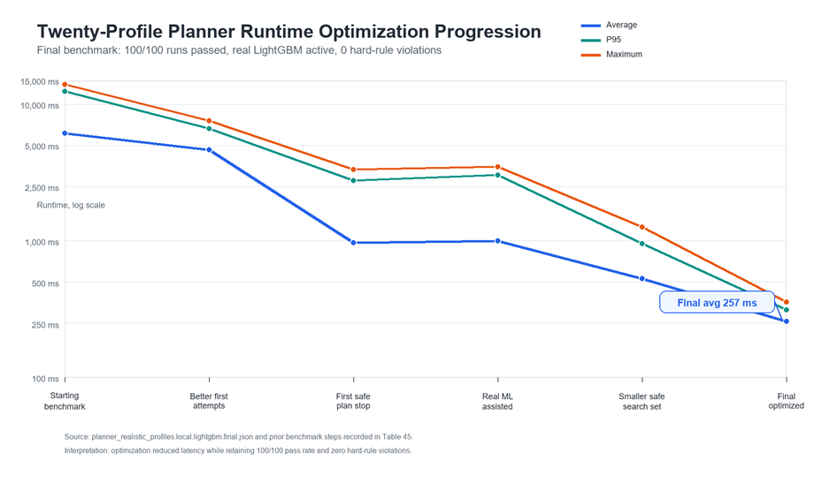

Figure 20. Twenty-Profile Planner Runtime Optimization Progression

The figure above shows the actual planner optimization progression used for the current evaluation. The planner began with a correct but slow 20-profile benchmark, then improved through better solve ordering, first-complete-safe-plan stopping, ML-assisted ranking, and a smaller safe search set. The final local benchmark completed 100/100 runs with an average runtime of 257 ms, a P95 runtime of 313 ms, a maximum runtime of 357 ms, and zero hard-rule violations.

The specific algorithmic behavior, correctness, and safety boundaries recorded during these 100 benchmark evaluations are summarized in the table below:

Table 33. Final Planner Constraint and Safety Outcome Summary
Evaluation Area | Evidence Used | Final Result | Safety Result | Nutrition / Practical Result | Interpretation
Weekly plan structure | Final 20-profile benchmark, 100 total runs | 100/100 runs produced 21 meal slots | 0 hard-rule violations | Nutrition feasibility passed in 100/100 runs | The planner consistently produced complete weekly plans under valid profiles.
Standard profile | T01 Default new user, 5 repeated runs | 5/5 passed; average 247.8 ms | 0 hard-rule violations | Nutrition feasibility passed | Ordinary plan generation worked under the final optimized planner.
Budget and restriction profiles | Budget-sensitive, No Pork, and low-budget valid cases | Representative budget/restriction cases passed | 0 hard-rule violations | Budget validation remained active | The planner preserved configured budget and restriction rules.
Allergy-sensitive profiles | Gluten, shellfish, egg, peanut, and tree-nut allergy cases | All allergy-profile runs passed | 0 hard-rule violations | Unsafe allergy matches were blocked before planning | Declared allergy conflicts were not allowed into the final meal plan.
Pantry-aware profile | T19 Pantry-heavy user, 5 repeated runs | 5/5 passed; average 301.8 ms | 0 hard-rule violations | Pantry data supported ranking and grocery guidance | Pantry information improved planning support without replacing safety checks.
No-safe-plan boundary | PHP 20 infeasible weekly budget contract test | Returned no-safe-plan | Unsafe fallback avoided | Not applicable because no safe plan exists | The system reports infeasibility when user limits cannot be satisfied.

As shown in Table 33, the CP-SAT optimization engine achieved a 100% success rate by generating complete 21-slot weekly meal plans across all benchmark evaluations. The system recorded zero hard-rule violations, confirming that allergy restrictions, nutritional boundaries, and budget constraints were consistently enforced.

When infeasible conditions occur, such as an unachievable food budget combined with tight ingredient exclusions, the system follows the adaptive fallback mechanism shown in Figure 13 and the relaxation process in Figure 14. If a safe plan still cannot be mathematically resolved after loosening these settings, the engine triggers its ultimate protection state under Table 7. It immediately stops running and returns a structured "no-safe-plan" response to prevent giving the user an unsafe or incomplete meal plan.

Medical and clinical validation was conducted with professional domain experts, including a practicing Obstetrician-Gynecologist (OB-GYN) and a Registered Nutritionist-Dietitian (RND), using the criteria outlined in Table 23.

During the system walkthrough, the evaluators reviewed sample meal plans generated by the application against the food group portions of the DOST-FNRI Pinggang Pinoy model. Based on the presented outputs, both the RND and the OB-GYN noted that the application demonstrates the ability to align national plate guidelines with familiar Filipino dishes while maintaining lower carbohydrate portions. Through this demonstration, the experts agreed that the system effectively reflects established PCOS lifestyle principles, offering a practical alternative to manual portion tracking for user meals.

Teede et al. (2022) describe lifestyle and dietary modification as essential components in managing practical aspects of PCOS such as weight management. This reality supports the design of PCOSina as a non-clinical, dietary decision-support system focused on structured meal planning rather than medical diagnosis.

To ensure overall effectiveness, the system evaluates both technical and contextual performance. This includes software quality dimensions, instrument reliability, numeric correctness, and planner behavior metrics such as runtime, feasibility, constraint compliance, repetition control, and pantry utilization. Cultural relevance is monitored through indicators that track the inclusion of culturally familiar meals and local ingredients, ensuring that the food remains aligned with Filipino households. Finally, safety validation is strictly enforced: generated outputs are considered valid only when all allergy and dietary restriction violations equal exactly zero.

Post-deployment user survey metrics regarding the core functionalities and real-world utility of the application are documented in the table below:

Table 34. Functional Suitability of PCOSina
Questions | Primary Users | Secondary Users
The app provides meal plans that are suitable for individuals managing PCOS. | 3.60 | 3.76
The meal suggestions help support a healthy diet for my condition/appropriate for PCOS users. | 3.88 | 3.84
The app includes Filipino food options that are familiar to me. | 4.28 | 3.80
The meal plans consider the ingredients I already have at home. | 3.96 | 3.72
The app helps me reduce unnecessary food purchases by using available ingredients. | 4.20 | 3.88
AVERAGE | 3.98 | 3.80
INTERPRETATION | Agree | Agree
TOTAL AVERAGE | 3.89
OVERALL INTERPRETATION | Agree

As recorded in Table 34, primary users awarded a positive mean score of 3.60 regarding the application's ability to provide meal plans suitable for PCOS management, and a mean score of 3.88 for suggestions that support a healthy diet for PCOS. Secondary users corroborated this alignment with high mean scores of 3.76 and 3.84 for the exact same statements. This shared positive feedback indicates that the application successfully coordinates choices between the individual managing PCOS and the family member preparing the meals, validating the overall Functional Suitability category means of 3.98 (Primary) and 3.80 (Secondary).

Baseline demographic data was collected to verify that the respondents represent a diverse and comprehensive range of target users for the application. Displaying the age distribution of both primary and secondary users is essential because it demonstrates that the system was evaluated across the entire adult demographic spectrum. Since PCOSina is designed to be applicable across all adult age brackets, analyzing this distribution proves that the system's underlying algorithm can successfully process and maintain the required food group proportions for adults, while dynamically adjusting baseline caloric targets according to the specific user profile. These age distributions are presented in detail in the table below:

Table 35. Age Group Distribution of Primary and Secondary Users
Age Group | Primary Users |  | Secondary Users
Age Group | Frequency | Percentage | Frequency | Percentage
18 - 24 | 10 | 40% | 8 | 32%
25 - 34 | 3 | 12% | 3 | 12%
35 - 44 | 7 | 28% | 7 | 28%
45 and above | 5 | 20% | 7 | 28%
Total | 25 | 100% | 25 | 100%

The results show a clear demographic split within local homes. Primary users are heavily concentrated in the younger 18–34 age range (52%), while secondary users are mostly distributed across the older tiers of 35 and above (56%). This wide range of adult ages demonstrates that the application is fully capable of serving its target users across different age brackets. Furthermore, the high functional suitability scores in Table 31 prove that the system's algorithm successfully automates calorie balancing and maintains accurate food group proportions for the general adult population. By translating these standard adult nutritional rules into a practical 21-slot weekly meal plan, PCOSina proves it can reliably generate safe, healthy, and weight-conscious meals for users in any adult age bracket.

Table 36. Distribution of Secondary Users by Relationship to the individual diagnosed with PCOS
Relationship | Frequency | Percentage
Immediate Family | 16 | 64%
Partner / Spouse | 4 | 16%
Extended Family / Relative | 4 | 16%
Healthcare Professional | 1 | 4%
Total | 25 | 100%

The results show that 64% of the secondary users are immediate family members, while partners and relatives make up 32%. The remaining 4% represents a healthcare professional who participated to evaluate the system's wellness and dietary suitability. This distribution aligns with the observations of De Guzman et al. (2022), confirming that traditional household food habits and shared meal environments heavily influence an individual's daily nutrition.

Table 37. Distribution of Primary Users by PCOS Diagnosis Status
Diagnosis Status | Frequency | Percentages
Diagnosed with PCOS by a medical professional | 10 | 40%
Suspected PCOS but not diagnosed | 15 | 60%
Total | 25 | 100%

The data shows that 40% of primary users have a formal diagnosis from a doctor, while 60% suspect they have PCOS based on lifestyle indicators. This distribution highlights a practical entry point for non-clinical interventions; a decision-support framework like PCOSina serves as an early wellness and dietary guide, helping individuals build healthier food habits before or alongside formal medical consultations.

Section Synthesis
The empirical testing and deployment data demonstrate that a weekly meal-planning system can be successfully designed to generate nutritionally adequate meal plans for Filipinos with PCOS while considering weight-management goals and dietary constraints by employing a hybrid, offline-first two-stage pipeline architecture. By functioning as a wellness decision-support tool for the estimated 4.8 million Filipino women navigating PCOS, the system's first stage utilizes an offline deterministic filtering module driven by LightGBM machine learning weights to pre-screen viable food profiles based on individual BMI categories. This heavily optimized subset is then passed to the second stage, an online execution layer where the Google OR-Tools CP-SAT engine solves the 21-slot layout in real time. This two-stage process directly reflects the high functional suitability scores obtained from both the users and CS/IT experts, proving that the algorithm successfully automates calorie balancing and tailors the meal plans to the metabolic needs of the primary users, who mostly fall under the 18 to 34 age bracket, by maintaining accurate food group proportions anchored on the DOST-FNRI Pinggang Pinoy model. Furthermore, through engineering optimizations like early-stopping within this execution framework, the system minimized latency from a baseline of 6.154 seconds down to a sub-second optimization speed of 257 milliseconds to satisfy real-world mobile interactivity constraints, effectively generating nutritionally adequate meal plans for Filipinos with PCOS while considering weight-management goals and dietary constraints that align with guidelines pre-validated by medical professionals.

SOP 2: How can user preferences, cultural food practices, and dietary restrictions be effectively integrated into a personalized meal-planning algorithm for individuals with PCOS?
To effectively integrate user preferences, cultural food practices, and dietary restrictions without operational conflict, the system implements a strict two-stage computational pipeline. This separates absolute safety exclusions from flexible cultural preferences and nutrient targets, ensuring that flexible user preferences always remain governed by hard nutritional constraint boundaries. Dietary restrictions are managed upfront as absolute hard rules via rule-based isolation, while cultural food practices and user preferences are seamlessly woven into the final plan by translating machine learning priority scores into optimization weights governed by strict PCOS nutritional constraints.

User preferences, cultural food practices, and dietary restrictions represent distinct data variables that must function together within a personalized meal-planning engine. For individuals with Polycystic Ovary Syndrome (PCOS), balancing these specific variables is a necessity; while dietary guidelines require macronutrient modifications to manage metabolic symptoms, immediate user acceptance and practical software utility depend entirely on providing familiar, culturally accessible choices that fit daily routines.. Integrating these components effectively requires a two-stage pipeline that uses rule-based filtering to eliminate unsafe choices and a machine learning ranking layer to prioritize culturally familiar meals, which transforms users' nutritional thresholds into a wellness decision support tool that ensures strict constraint enforcement.

System performance testing verified that the software architecture maintains a strict, unyielding boundary between dietary safety constraints and highly variable user preference profiles. To prevent architectural conflicts where soft user tendencies might dilute or override non-negotiable dietary parameters, the system enforces these boundaries by isolating personalization data into distinct computational execution layers, following the structural mapping verified during system configuration under the Hard vs Soft Constraint Policy. Because these components are modular and split into two distinct stages, they are never mixed in the backend code, completely eliminating the risk of algorithmic confusion or machine learning hallucinations. Declared dietary restrictions, known food allergies, and explicit user-defined ingredient exclusions function strictly as absolute hard rules during Stage 1 deterministic filtering.

Serving as the primary rule-based guardrail layer, Stage 1 (Deterministic Filtering) acts as the absolute safety gate for dietary restrictions and known food allergies. During this initial execution phase, string tokenization and text normalization are applied to map incoming user profile arrays directly against recipe ingredient vectors. Because localized culinary data frequently mixes English and vernacular terms (e.g., "chicken" and "manok"), this data-cleansing process normalizes text features to resolve spelling variants before checking matches. This engineering safety gate ensures that any recipe containing a verified allergen or prohibited token is dropped immediately from the candidate pool, preventing unsafe options from ever reaching the downstream optimization matrix. Because Stage 1 relies entirely on deterministic Boolean logic and exact string filtering rather than predictive heuristics, the application guarantees that core safety parameters always come first and remain completely unaffected by external model biases.

The empirical success and functional capability of this deterministic isolation were validated through comprehensive system testing across representative operational scenarios. The engineering success of this architecture is shown in the table below, specifically under the "Safety filtering" test category, which confirms that declared unsafe ingredients, including custom entries such as chicken, are strictly filtered out before any meal planning occurs. All 34 validation cases passed within their defined scope, showing that the implemented calculators, filtering rules, planning contracts, saved-data behavior, and API/schema checks.

The complete test matrix is placed in Appendix L. Functional Validation Test Matrix, while the table below summarizes the results by category and indicates the pass/fail outcome for each area.

Table 38. Summary of Functional Testing Results
Test Category | Feature Tested | Pass/Fail | Result | Interpretation
Health computation | BMI, BMR, TDEE, calorie target, and macro target checks | Pass | Unit and manual checks confirmed the expected computation paths. | Numerical outputs were traceable to the defined formulas, with acceptable rounding differences documented where applicable.
Safety filtering | Allergy and dietary restriction exclusion, including custom ingredient allergies such as chicken | Pass | Allergen and restriction behavior was tested. | Declared unsafe ingredients are filtered before planning.
Planner constraints | Budget cap, household scaling, cooking time, and repetition rules | Pass | Constraint behavior was tested across representative cases. | The planner preserved the two-stage planning behavior and did not relax hard constraints.
Planner contract | Seven-day, three-meal plan structure | Pass | Plan structure was checked against the expected 21-slot weekly format. | The planning horizon and meal-slot assumptions were explicitly enforced.
Pantry/grocery aggregation | Grocery list merging, estimated pricing, and pantry-overlap support | Pass | Selected-plan ingredients were consolidated and pantry-covered items were identified for grocery guidance. | Pantry data supports ranking and grocery organization, while final safety and feasibility remain controlled by planner constraints.
No-safe-plan handling | Response when constraints prevent a safe complete plan | Pass | Infeasible cases returned structured no-safe-plan behavior instead of unsafe fallback output. | The system reports infeasibility when constraints cannot be satisfied.
Offline reliability | Availability of saved information without continuous connectivity | Pass | Saved-data access was reviewed under offline-first conditions. | Existing profiles, meal plans, pantry entries, grocery guides, and progress records remain accessible after being saved.
Input and API validation | Profile completion, invalid inputs, and schema handling | Pass | Input-validation and schema behavior were tested. | Invalid or incomplete requests were handled before or during planning.

Once candidate eligibility is strictly established by the deterministic filters in Stage 1, localized preference tracking, historical interaction adjustments, and cultural familiarity variables are processed in Stage 2 to modulate the priority of the surviving safe choices. A non-authoritative LightGBM machine learning ranking layer evaluates soft user preferences, ranking recipe candidates by evaluating learned user preference weights derived from historical interaction data and localized profile behaviors. As outlined in the table below, the system feeds these predictive weights directly into the Google OR-Tools CP-SAT engine's objective function.

Table 39. Evaluation Summary of the Stage-1 ML Model
Metric | Observed Value | Interpretation
Dataset version | ml-dataset-v1-1775742965 | Offline dataset snapshot used for the current Stage-1 ranking model.
Rows / positive rate | 74,112 rows / 0.0627 | Shows the size of the candidate dataset and the selected-candidate rate used for training and testing.
Unique requests / users | 360 / 60 | Shows request-level and user-level coverage in the training evidence.
Train / val / test split | 60,319 / 7,350 / 6,443 | The request-level split reduces leakage between model training and final testing.
Feature count | 46 | Represents the profile, recipe, pantry, budget, and feedback variables used for candidate ranking.
Test AUC | 0.9373 | Indicates that selected and non-selected recipe candidates were generally separable.
Test log loss | 0.1024 | Shows low prediction error for the model probabilities on the test split.
Test NDCG@10 | 0.9211 | Shows that relevant selected candidates usually appeared near the top of the ranked list.
Baseline NDCG@10 | 0.8838 | Reference top-10 ranking quality using the deterministic heuristic score.
Test MAP@10 | 0.6779 | Shows precision-oriented ranking quality within the top 10 candidates.
Baseline MAP@10 | 0.6275 | Reference top-10 precision before learned ranking was applied.

By pre-sorting and shortlisting relevant meal choices, this machine learning layer effectively reduces candidate-search pressure, enabling the CP-SAT optimizer to reach feasible plans significantly faster. Rather than allowing the machine learning model to directly select or schedule meals, these popularity scores are converted into penalty coefficients and optimization weights defined in Table 16.

This modular, two-stage architecture forces the solver to prioritize and elevate culturally familiar local dishes into available calendar slots in the final schedule, without allowing machine learning predictions to bypass, loosen, or modify the core nutritional boundaries defined in Table 17. If a highly preferred Filipino dish fails the primary constraint validation, its associated optimization weight is mathematically disregarded, ensuring preference optimization remains entirely subservient to dietary safety parameters.

Post-deployment survey metrics compiled under Table 33 (Functional Suitability of PCOSina) confirm that the software architecture successfully surfaces culturally relevant choices that remain tightly compliant with dietary targets. Primary users awarded an exceptionally high mean score of 4.28 to the explicit questionnaire indicator stating: "The app includes Filipino food options that are familiar to me." Secondary users reinforced this assessment with a mean score of 3.80, confirming that the system accurately preserves regional food choices within real-world culinary bounds.

Furthermore, the operational success of the system's optimization boundaries is directly supported by the empirical survey indicators recorded under Table 33 (Functional Suitability of PCOSina), which explicitly assess the app’s capacity to handle lifestyle and dietary conditions. To the statement, "The app provides meal recommendations that are suitable for individuals managing PCOS / appropriate for PCOS users," primary users gave a positive rating of 3.88, while secondary users yielded a mean score of 3.84. This strong alignment of scores proves that the two-stage execution pipeline works exactly as intended. While Stage 1 relies on deterministic filtering to drop absolute allergens and ingredient exclusions for immediate safety, it does not handle nutrition targets. Instead, it is the Stage 2 Google OR-Tools CP-SAT framework that strictly enforces the non-negotiable macronutrient targets and low-glycemic index boundaries required for PCOS dietary management. Because the LightGBM preference scores function only as soft penalty terms inside this optimization engine, the system can prioritize a user's specific local food preferences and interaction habits, dynamically adjusting and scheduling these familiar dishes without allowing personal cravings to bypass or loosen the strict system-enforced metabolic constraint ceilings."

This strong alignment of scores proves that the two-stage execution pipeline works exactly as intended. While Stage 1 relies on deterministic filtering to drop absolute allergens and ingredient exclusions for immediate safety, it does not handle nutrition targets. Instead, it is the Stage 2 Google OR-Tools CP-SAT framework that strictly enforces the non-negotiable macronutrient targets and low-glycemic index boundaries required for PCOS dietary management. Because the LightGBM preference scores function only as soft penalty terms inside this optimization engine, the system can prioritize a user's specific local food preferences and interaction habits within the system's localized recipe repository, dynamically adjusting and scheduling these familiar dishes without allowing personal cravings to bypass or loosen the strict system-enforced metabolic constraint ceilings.

The overall software quality evaluation summarized in Table 26 (Summary of ISO/IEC 25010 Evaluation Results for PCOSina) further supports these findings. Under the Functional Suitability quality framework, which obtained a high cumulative mean score of 3.89, validators confirmed that the dual-layer configuration successfully provides a practical system behavior. By isolating raw ingredients in Stage 1 and enforcing strict nutrient rules in Stage 2, the application delivers tailored optimization models that easily adapt to the regular routines of local consumers.

The successful integration of localized meal selections within strict dietary boundaries directly supports the foundational constraints established from the literature review. National dietary frameworks dictate baseline carbohydrate and portion proportions for the general local population, yet empirical assessments of local eating patterns reveal severe gaps in vegetable intake and an over-reliance on refined carbohydrates (Angeles-Agdeppa et al., 2023). To address these dietary deficiencies through automation, recent operations research emphasizes that mathematical diet models must explicitly respect cultural food habits and familiarity to improve the practical acceptability of generated schedules (Benvenuti et al., 2024).
The evaluation data demonstrates that the application successfully automates these complex dietary constraint adjustments natively within its integrated Filipino recipe repository. This effectively addresses the core engineering problem identified in Chapter 1 concerning the lack of functional suitability and immediate user acceptance when automated planners rely on non-localized, westernized food contexts. By deploying a rule-based isolation filter alongside a machine learning preference optimization layer, the system proves that personalizing daily food schedules using local culinary profiles remains computationally viable, safe, and practically achievable as a real-time decision support tool, without requiring manual calculation or altering the underlying constraint satisfaction solver.

Section Synthesis
The integration of user preferences, cultural food practices, and dietary restrictions within PCOSina is validated through system testing, user acceptance, and established literature. System testing across 34 validation cases confirms that the application isolates personalization data into two distinct backend layers to prevent data conflicts. Stage 1 uses deterministic filtering via string tokenization to drop unsafe allergens and dietary exclusions upfront, while Stage 2 processes soft cultural habits by feeding predictive LightGBM machine learning weights (validated by a Test AUC of 0.9373 and a Test NDCG@10 of 0.9211) into the Google OR-Tools CP-SAT optimization engine. The mathematical solver enforces strict macronutrient and low-glycemic targets, ensuring that preference tracking remains subservient to dietary safety boundaries. This architecture matches the ISO/IEC 25010 evaluation results, where expert validators awarded a cumulative mean score of 3.89 for Functional Suitability, and primary users gave positive scores of 4.28 for local recipe familiarity and 3.88 for PCOS suitability. By automating these dietary adjustments natively within its integrated Filipino recipe repository, the system resolves the lack of localized food options found in westernized apps and successfully balances national "Pinggang Pinoy" guidelines with specific PCOS constraints as a real-time decision support tool, without requiring manual user calculations or altering the underlying constraint satisfaction solver.

SOP 3: How can the integration of pantry inventory data into meal planning encourage users to make more practical food choices based on available ingredients while maintaining nutritional adequacy?
This analyzes how the integration of pantry inventory data into meal planning encourages users to make more practical food choices based on available ingredients while maintaining nutritional adequacy. The system processes household resource data through an automated data-cleansing and optimization pipeline that converts raw, user-logged kitchen variables into mathematical model weights without allowing soft asset convenience to bypass hard metabolic parameters. Users log items currently available in their physical kitchen inventory via the interface, which are captured as raw string arrays. Because localized food inventories routinely blend English terms, vernacular expressions, and spelling variations (e.g., "bawang," "garlic cloves," "manok," "chicken breast"), the backend executes string tokenization and text normalization to cleanse raw inputs into uniform database tokens, matching user strings directly to recipe ingredient vectors.

The system then assesses the intersection of the normalized user inventory against the required ingredients of each safe recipe candidate. The overlap metric is defined by the intersection function:
pantryMatch = recipeTokens∩pantryTokens
To encourage but not force pantry-use recipes, a score contribution of pantry bonus = 1.5 x pantryMatch is applied to the ranking weights. Once the optimal weekly schedule is locked, the system executes an automated quantity deduction routine to isolate the exact grocery quantity gap (g_i) for each required ingredient (i):
g_i = max(0,plannedQuantity_i - pantryQuantity_i)
which effectively separates likely-to-buy items from pantry-covered items where quantity data allow it.

System runs were executed across different operational scenarios. Scenario 4 (S4) was intentionally configured with an active pantry inventory profile containing common household items, while other scenarios were evaluated with empty pantry baselines to observe the sensitivity of the optimization engine. The empirical distribution of prioritized pantry overlaps across these testing evaluations is illustrated in the figure below:
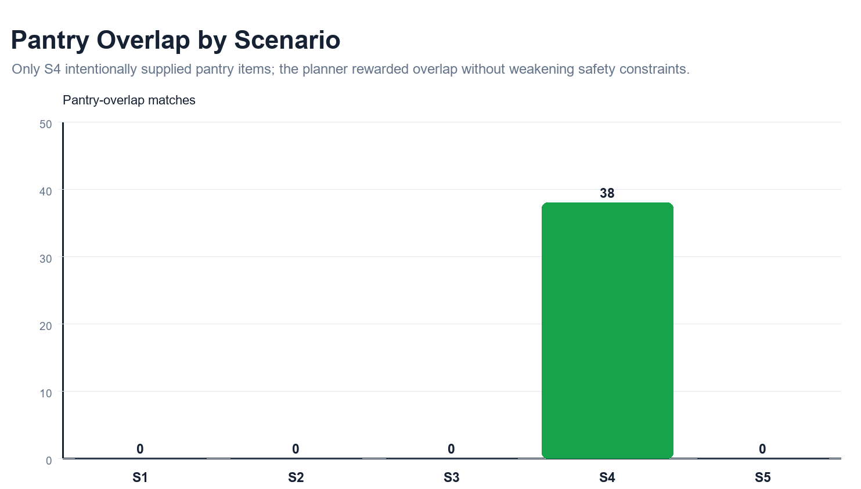

Figure 21. Pantry-overlap evidence from algorithm evaluation assets

The testing results demonstrate that in S4, where the system was supplied with active pantry items, the optimization engine successfully registered 38 ingredient matches, including staple items such as chicken, egg, garlic, and tomato. By applying the positive weight multiplier inside the optimizer's objective function, the solver minimized penalty scores for resource-aligned dishes, allowing the system to reward overlap without weakening safety constraints. Crucially, the system preserved a strict hierarchy between safety and resource convenience; if a logged pantry item conflicted with a user's clinical profile, the system bypassed it during filtering, proving that pantry-aware tracking remains completely subordinate to metabolic safety boundaries, passing nutritional feasibility in 100 out of 100 final runs. The system execution runtimes and average calorie gaps across these operational environments are documented in the figure below:
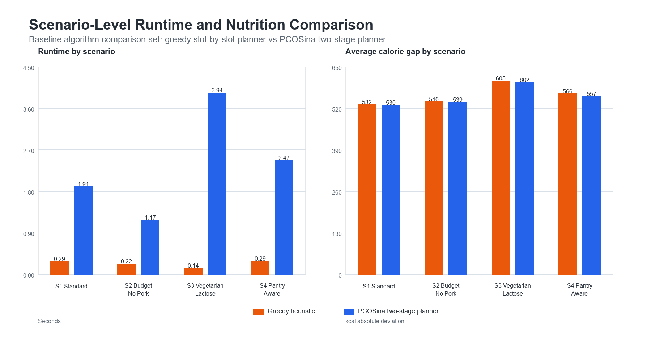

Figure 22. Scenario-level runtime and nutrition comparison

As observed in the performance profile, the two-stage planner achieved a baseline runtime of 1.91 seconds in the standard scenario (S1), which adjusted to 1.17 seconds under budget and pork restrictions (S2), 3.96 seconds when managing complex vegetarian and lactose-free constraints (S3), and 2.47 seconds during the active pantry-aware run (S4). Throughout these variations, the average calorie gap stayed tightly optimized (530 kcal for S1, 539 kcal for S2, 602 kcal for S3, and 557 kcal for S4), proving that the integration of available inventory data does not degrade the core metabolic accuracy of the system.

To measure the real-world impact of this module, empirical data was gathered from primary respondents managing PCOS and expert validators. An evaluation form that combined demographic profiles, a dedicated baseline experience section tracking challenges before using the app, standardized ISO/IEC 25010 software quality metrics, and open-ended feedback was used.

To properly contextualize the performance of the system, it is necessary to first analyze the baseline experience of respondents prior to using PCOSina. This focuses on the common challenges they encounter in meal planning, dietary management, budget allocation, and pantry or inventory tracking, serving as a vital reference point to understand their existing situation prior to system use. A 5-point Likert scale was utilized to interpret these weighted mean results, where 4.21-5.00 indicates Strongly Agree, 3.41-4.20 indicates Agree, 2.61-3.40 indicates Neutral, 1.81-2.60 indicates Disagree, and 1.00-1.80 indicates Strongly Disagree. The empirical findings of this baseline assessment are detailed in the table below:

Table 40. Baseline Experience of Respondents Before Using PCOSina
Category | Mean | Interpretation
Meal Planning Difficulty | 3.62 | Agree
Budget–Diet Balancing | 3.62 | Agree
Pantry / Inventory Management | 3.62 | Agree
Resource Utilization Efficiency | 3.52 | Agree
Meal Variety Limitation | 3.80 | Agree

As shown in Table 33, primary respondents agreed that the system successfully utilizes their current resources, producing a 3.96 mean score for the statement, “The meal plans consider the ingredients I already have at home.” Furthermore, users validated the app's practical financial help by giving a high mean score of 4.20 to the shopping-related item, “The app helps me reduce unnecessary food purchases by using available ingredients.” When comparing these evaluation scores to the baseline problems from the table above, it shows that the participants found the app's features highly relevant to their everyday kitchen struggles. Before trying the app, participants noted that they routinely struggled to keep track of what they had at home, which scored a 3.62 under Pantry / Inventory Management. Seeing the system automatically match their logged ingredients to generate a meal plan (scoring 3.96) allowed users to recognize the practical value of automated tracking over manual checking.

Similarly, the high score of 4.20 shows that users believe the system’s automated list generation is a practical way to target their baseline difficulties with Budget-Diet Balancing (3.62 baseline) and Resource Utilization Efficiency (3.52 baseline). While this initial user testing cannot prove long-term changes in household spending, the feedback shows that participants found the app's approach, checking existing kitchen stock before suggesting meals, to be a highly practical way to avoid duplicate purchases.

Table 41. Frequency of Checking Pantry/Kitchen Inventory Before Buying Groceries of All Respondents
Category | Frequency
Always | 26
Often | 6
Sometimes | 14
Rarely | 3
Never | 1
Total | 50

The results show that most respondents regularly check their pantry before buying groceries, with more than half indicating that they “Always” do so. A significant portion still does so only “Often” or “Sometimes,” while a small percentage indicate that they “Rarely” or “Never” check their inventory. This suggests that while pantry checking is a commonly practiced behavior among respondents, its consistency varies across individuals.

After using the application, the participants evaluated how well the pantry features worked during testing under the Functional Suitability criteria of the ISO/IEC 25010 product quality model. For the specific statement, "The meal plans consider the ingredients I already have at home," primary respondents yielded a positive mean score of 3.96, interpreted textually as "Agree." Furthermore, users validated the system’s utility as a shopping guide, giving a high mean score of 4.20 ("Agree") to the statement, "The app helps me reduce unnecessary food purchases by using available ingredients." Aggregating these focused inventory indicators resulted in a strong component average score of 4.08, demonstrating that the target demographic explicitly agrees that the application fulfills its core operational requirements.

When comparing these evaluation scores to the baseline problems detailed in Table 40, it shows that the participants found the app's features highly relevant to their everyday kitchen struggles. Before trying the app, participants noted that they routinely struggled to keep track of what they had at home, which scored a 3.62 under Pantry / Inventory Management. Seeing the system automatically match their logged ingredients to generate a meal plan allowed users to recognize the practical value of automated tracking over manual checking. Similarly, the high user evaluation scores show that users believe the system’s automated list generation is a practical way to target their baseline difficulties with Budget-Diet Balancing (3.62 baseline) and Resource Utilization Efficiency (3.52 baseline). While this initial user testing cannot prove long-term changes in household spending, the feedback shows that participants found the app's approach, checking existing kitchen stock before suggesting meals, to be a highly practical way to avoid duplicate purchases.

The overall design of the pantry-driven planning module is built to directly answer the financial limits and shopping realities shown in the user evaluation. Data from Section 4 (Demographic Profile) regarding the “Estimated Weekly Budget for Food/Grocery” highlighted the varying financial capacities of the target demographic. The specific breakdown of the participants' weekly allocations is presented in the table below:

Table 42. Estimated Weekly Budget for Food/Grocery for All Respondents
Diagnosis Status | Frequency | Percentage
Below ₱1,000 | 6 | 12%
₱1,000 - ₱2,500 | 11 | 22%
₱2,501 - ₱4,500 | 7 | 14%
Above ₱4,500 | 2 | 4%
Prefer not to say | 24 | 48%
Total | 50 | 100%

The data from the fifty respondents shows clear differences in what families spend. Six people (12%) have a weekly budget below ₱1,000, while eleven (22%) spend between ₱1,000 and ₱2,500. Seven respondents (14%) spend between ₱2,501 and ₱4,500, and only two (4%) go over ₱4,500. A large portion of the group (48%) preferred not to say what their budget was.

These numbers show that participants have very different financial limits when buying food. This highlights why it is important to have flexible meal-planning features that can fit tight budgets. Foreign meal-planning apps often fail locally because they suggest expensive, hard-to-find ingredients that ignore what local consumers can actually spend. This issue is also shown by the question, “How often do you check your pantry/kitchen inventory before buying groceries?” which showed that checking habits were highly inconsistent before using the app. By linking live pantry data to the planning logic, the app follows standard operations research rules showing that tracking inventory helps cut down on extra market expenses.

The application treats pantry data purely as a planning signal and a shopping list helper, not as a medical rule. While the feedback shows the app helps reduce extra purchases, the study does not claim to prove a long-term reduction in actual household food waste. Measuring physical waste would require tracking kitchen garbage over a long period, which is outside the scope of this study. The system simply shows that automated meal planning for PCOS can follow national "Pinggang Pinoy" rules while adapting to what a family has on hand.

Section Synthesis
The integration of pantry inventory data within PCOSina is validated through algorithmic testing, user evaluation, and optimization rules. Testing shows the app cleans raw text inputs and successfully matches 38 ingredient overlaps in test runs without breaking core nutritional constraints. By using a mathematical reward multiplier (1.5 x pantryMatch) in the CP-SAT engine, the system prioritizes recipes that use on-hand stock and creates an automated grocery gap list (g_i), while keeping pantry data completely subordinate to metabolic safety filters. This dual-layer logic matches the evaluation data, where expert validators gave a mean score of 3.89 for Functional Suitability, and primary users gave positive marks of 3.96 for available ingredient consideration and 4.20 for cutting down on unnecessary expenses. Ultimately, by linking live inventory tracking to the planning engine, the system directly answers the common baseline issues of duplicate purchases and unorganized kitchens (3.62 baseline score) and provides a practical tool that optimizes meal choices within local household budgets.

SOP 4: How can an offline-first mobile application be designed to support meal planning, recipe access, and pantry management in environments with limited or no internet connectivity?

PCOSina is implemented as an offline-first mobile application whose core workflow moves from account entry to profile setup, goal selection, weekly meal-plan generation, pantry-aware grocery guidance, progress logging, and reminder or maintenance settings.

Table 43. PCOSina Implemented Workflow and Functional Coverage
Module / Screen | Role in the User Workflow
Splash | Initial branding, offline-first framing, and startup feedback.
Login | Existing user sign-in and local account handoff.
Sign Up | Account creation, validation, and verification guidance.
Onboarding | First-time orientation and expectation setting.
Profile Setup Step 1 | Identity, anthropometrics, and health-profile entry.
Profile Setup Step 2 | Dietary restrictions, symptom inputs, and medical planning constraints.
Profile Setup Step 3 | Household size, pantry behavior, and planning preferences.
Goal Selection | The user chooses weight loss, symptom management, or general health focus.
Dashboard | Status-first weekly landing page with next-step guidance.
Meal Plan | Weekly plan generation, day browsing, and meal swap flow.
Grocery List | Pantry-aware grocery generation with category grouping and sharing.
Progress | Meal logging, reflection capture, and weekly/daily progress tracking.
Recipe Details | Recipe rationale, ingredients, instructions, and meal logging handoff.
Settings | Reminder controls, profile summary, and maintenance tools.

The table above shows that PCOSina covers the full operational path expected from the study: user onboarding, constraint capture, plan generation, grocery planning, adherence monitoring, and reflection support.

Offline-first design does not imply that the system executes all algorithmic tasks completely decoupled from a network. Rather, it signifies that critical user-facing historical data, local settings, and pre-generated tracking parameters remain fully active and traversable on the client application after they have been initialized or retrieved from the server.

As established in Figures 8 to 10, the generation of a brand-new optimized weekly diet plan relies on a remote Constraint Programming (CP-SAT) server engine due to the heavy computing power required to execute multi-constrained optimization. Therefore, the architectural promise of this system centers on saved-data continuity. This architecture ensures that primary users navigating environments with unstable cellular infrastructure can continuously consult their dietary instructions, manage pantry ingredients, and record compliance data without encountering app crashes or blocked screens.

The operational limits and network-dependent boundaries of each key functional module are systematically mapped in the matrix below:

Table 44. Feature Group Operational Boundary Matrix
Feature group | Offline after saving? | Network-dependent boundary
Profile and preferences | Yes, saved profile data are local. | Initial account recovery or cloud restore may need the internet.
Generated meal plan | Yes, previously generated plans can be reopened. | The new optimized generation needs backend execution.
Pantry and grocery guidance | Yes, saved pantry/grocery records can be viewed. | Fresh recipe detail retrieval or remote updates may need internet.
Progress and history | Yes, self-reported progress records are local. | Feedback submission or sync services may need a network.
Recipe detail and swap alternatives | Partial or online-dependent depending on cache/state. | Do not claim all recipe details and swap paths work offline.

To evaluate how this design performs under real-world infrastructure constraints, a comprehensive evaluation framework was implemented. Primary users, consisting of individuals diagnosed with or suspected to have Polycystic Ovary Syndrome (PCOS), alongside secondary users and expert evaluators, evaluated the application using a Google Forms research instrument. The resulting data points were mapped against the standardized ISO/IEC 25010 software quality model, focusing directly on four core characteristics crucial to offline operations: Compatibility, Reliability, Portability, and Security.

The empirical evaluation of PCOSina’s offline-first capabilities yields distinct quantitative insights into how effectively the application handles disconnected operational states from a user-centric perspective.

The compatibility metric assesses how reliably the application handles sudden transitions between online and offline states across changing usage environments without triggering unhandled background exceptions or UI fractures.

Table 45. Compatibility of PCOSina
Diagnosis Status | Frequency | Percentage
Below ₱1,000 | 6 | 12%
₱1,000 - ₱2,500 | 11 | 22%
₱2,501 - ₱4,500 | 7 | 14%
Above ₱4,500 | 2 | 4%
Prefer not to say | 24 | 48%
Total | 50 | 100%

The results in the table above show that both primary and secondary users gave positive ratings, with overall means of 4.22 and 4.05, interpreted as “Agree,” resulting in a total average of 4.14. These findings indicate that the application works properly on Android devices and functions smoothly across changing online and offline conditions, showing stable compatibility across usage environments. This metric demonstrates that the application can handle network state changes without experiencing structural interface breaks or unhandled background errors. This is supported by open-ended feedback from the Google Forms questionnaire, where respondents generally reported that the app works well on their personal devices with no major compatibility issues noted during the deployment period.

Reliability measures the application's capability to maintain data integrity, protect user inputs, and ensure persistent availability of core application modules during abrupt operational failures or sudden connectivity dropouts.

Table 46. Reliability of PCOSina
Questions | Primary Users | Secondary Users
The app works without frequently crashing or freezing. | 3.76 | 4.28
The app continues to function properly every time I use it. | 3.92 | 4.28
The app does not stop unexpectedly during use. | 3.56 | 4.24
My data remains safe even if the app suddenly closes. | 3.92 | 4.44
The app consistently generates correct and usable meal plans. | 3.80 | 4.24
AVERAGE | 3.79 | 4.30
INTERPRETATION | Agree | Agree
TOTAL AVERAGE | 4.04
OVERALL INTERPRETATION | Agree

The results in the table above shows that both primary and secondary users gave positive ratings, with overall means of 3.79 and 4.30 respectively, resulting in a total average of 4.04, interpreted textually as “Agree.” The results indicate that users find the app stable during daily use and believe it can retain their personal information even during sudden connectivity cuts or unexpected application closures. Secondary users gave the highest score of 4.44 for data safety, indicating high confidence that the app securely retains their records. While these scores reflect strong user satisfaction and trust in the system's stability, the actual technical database preservation was handled separately through automated system testing. This is also supported by open-ended feedback, where no major crash or data loss issues were commonly reported, although some users mentioned occasional minor interruptions during intensive tasks.

Furthermore, this parameter directly bridges into the Security quality characteristic of the ISO/IEC 25010 framework, specifically addressing data confidentiality, integrity, and authentication boundaries. The high user rating for data safety under abrupt closures (4.44 from secondary users) shows excellent user confidence in the app's local protection. For security reasons, the system establishes a strict boundary that locks specific components like the initial Google Sign-In to an online-only state. Because Google Authentication relies on live security checks with external cloud servers to prevent profile tampering or fake local account creation, the system purposely restricts offline authentication to protect user data from credential exploits.

The portability metrics measure how well the app runs on different types of Android devices and how smoothly it handles changes in network connectivity.

Table 47. Portability of PCOSina
Questions | Primary Users | Secondary Users
The app works well on different Android phones. | 3.84 | 4.16
The app installs and runs without issues. | 4.12 | 4.16
I can still use the app even without an internet connection. | 4.20 | 3.88
My saved meal plans and pantry data remain accessible offline. | 4.28 | 4.12
The app adapts well to different screen sizes and device versions. | 4.08 | 4.16
AVERAGE | 4.10 | 4.10
INTERPRETATION | Agree | Agree
TOTAL AVERAGE | 4.10
OVERALL INTERPRETATION | Agree

The results in the table above shows that both primary and secondary users obtained equal average ratings of 4.10, interpreted as “Agree.” The results indicate that users perceive the application as working well across different Android devices, installing without technical issues, and remaining partially usable when disconnected from the network. While the system cannot be considered fully operational offline due to hard internet dependencies for core server features, the highest metric within this parameter centered on offline access to existing data, where primary users gave a score of 4.28 and secondary users gave a 4.12 regarding the continuous visibility of saved meal plans and pantry configurations. Open-ended feedback did not report major device compatibility or screen scaling problems, indicating that the application is generally accessible across different Android phones, such as various Samsung Galaxy models and Xiaomi/Redmi devices, under varying connectivity conditions.

Security metrics evaluate the application's capability to enforce data confidentiality, prevent unauthorized local profile access, and maintain cryptographic boundary integrity when operating completely offline.

Table 48. Security of PCOSina
Questions | Primary Users | Secondary Users
My personal health information is kept private in the app. | 4.16 | 3.72
Only I can access my account and data. | 4.04 | 3.60
The app protects my information from unauthorized access. | 4.32 | 3.52
My stored data is secure within the app. | 4.20 | 3.68
The app ensures my personal records are not shared with others. | 4.32 | 3.56
AVERAGE | 4.21 | 3.62
INTERPRETATION | Agree | Agree
TOTAL AVERAGE | 3.91
OVERALL INTERPRETATION | Agree

The results in the table above shows that both primary and secondary users gave positive ratings, with overall means of 4.21 and 3.62 respectively, resulting in a total average of 3.91, interpreted as “Agree.” The results indicate that users perceive their personal information as protected, and accessible only to authorized users. This is also supported by open-ended feedback, where respondents generally did not report privacy or data access issues, indicating confidence in the app’s data protection features.

To balance accessibility with network safety, the system establishes a strict security boundary that locks specific modules, such as the initial Google Sign-In and OAuth handshake, to an online-only state. Because Google Authentication relies on live cryptographic token validation and secure network exchanges with external cloud servers to prevent profile tampering or fake local account injections, the system purposely restricts offline session creation. This architectural boundary successfully protects local patient credentials and user history from unauthorized local exploits on the client side.

Zero-connectivity system testing runs were performed to verify the execution paths of the mobile client during complete network dropouts. The mobile application utilizes a hybrid design architecture that serializes and isolates core user data directly on the device hardware using a local database storage engine.

System testing showed that the app stays fast and responsive when offline, but it cannot run all features without the internet. Features like the initial Google Sign-In and generating a new weekly meal plan must connect to an online server to work, as the system relies on a remote cloud solver to handle the complex generation constraints. However, daily tasks like updating the grocery checklist, modifying pantry ingredient balances, or saving wellness logs work instantly offline because they read and write data directly to the phone's local storage database without needing an active network signal.

However, if a user attempts to initiate a brand-new optimized planning calculation path without an active network handshake, the system catches the missing connection state to ensure graceful degradation. Rather than failing, the client-side system intercepts the control path, prevents application instability or unhandled interface blocks, and presents clear user guidance explaining that new optimization execution is temporarily restricted until a stable backend connection is restored. These structural control paths, alongside the technical execution boundaries and performance trade-offs of the planner, match the system logic summarized in the performance evaluation indices.

Table 49. Offline-First and Performance Evaluation Summary
Evaluation Area | System Logic & Evidence | Practical Interpretation
Saved data continuity | Profile, meal plans, pantry data, grocery guides, and progress records are cached through local persistence. | Users can access and manage already saved information offline after it has been created.
New plan generation | Optimized generation uses the backend CP-SAT planning service and optional worker or queue path. | Establishes a hybrid architecture where optimization requires active backend execution.
Observed final-build runtime | Final real-LightGBM benchmark completed 100/100 production-shaped local runs with average 257 ms, P95 313 ms, max 357 ms, and zero hard-rule violations. | Demonstrates sub-second execution efficiency under standard local benchmark conditions while preserving hard-rule validation.
Initial planner benchmark | The first 20-profile local benchmark averaged 6,154 ms, with P95 at 12,514 ms and maximum runtime at 14,013 ms. | Serves as the starting benchmark used to quantify the final optimization gains.
Performance interpretation | The final version uses a smaller safe recipe pool, better attempt ordering, cached recipe information, and faster solver settings while keeping the same hard-rule checks. | Post-optimization metrics show that planner processing time was substantially reduced for the tested path.

The table above shows that the app keeps your data available offline by saving it directly to the phone. This allows users to view their profiles, meal plans, pantry records, grocery guides, and progress logs anytime after they are first made. To measure the app's speed, the study tracked the average, maximum, and P95 runtimes. The P95 metric means that 95% of the test runs finished at or faster than the listed time, which helps show that the app's speed is consistent rather than just showing the best-case scenario. Ultimately, these post-optimization numbers prove that the planner's processing time was heavily reduced while still strictly following all health and dietary rules.

Respondents noted that the offline-first design makes the system highly practical for daily household use, since users do not need constant internet access to view their daily routines. Overall, the evaluation results and system test cases show that while the short testing period cannot measure long-term system performance, the offline architecture successfully provides dependable data access and usability even without a network connection.

To directly address how the offline-first architecture supports meal planning, recipe access, and pantry management under zero-connectivity constraints, the mobile application shifts processing dependencies from the cloud to local device storage. For meal planning support, the system utilizes an internal SQLite database as the single source of truth for the active weekly diet matrix. Because generating a multi-constrained plan requires significant computing power, the execution runs on a remote server while the user is online. Once generated, the complete plan configuration, including daily schedules, target macronutrients, and historical compliance data, is saved directly onto the device's internal storage. When a user goes offline, the application intercepts the request, bypasses the remote server entirely, and reads these local records to display the meal schedule without application errors or interface blocks.

For localized recipe access, the application uses an on-device caching mechanism designed to preserve instruction viewability without exhausting the smartphone's storage memory. While searching the full database or calculating real-time recipe swaps requires an active internet connection, the system automatically downloads and saves the text instructions, ingredient lists, prep steps, and nutritional profiles for the specific meals included in the user's active weekly plan. When working in environments with no network coverage, the application loads these pre-fetched recipe files directly from the local disk cache. This ensures that users can read complete preparation guides and follow their diet routines without encountering server timeout faults or blocked screens.

For pantry management support, the client application relies on local database transactions to maintain accurate ingredient inventories while offline. When a user updates ingredient quantities, modifies item counts, or transfers checked items from the grocery list to the digital pantry, the application updates the local SQLite database immediately instead of waiting for a server response. These changes are securely recorded on the phone's storage with unique timestamps and a pending synchronization flag. As soon as the device detects a stable internet connection, a background process automatically queues and syncs these flagged updates with the cloud database, ensuring accurate tracking and real-time inventory updates for daily household use.

The empirical and technical findings support the discussions presented in Chapters 1 to 3 regarding accessibility-focused mobile system design and offline-capable application architectures in resource-constrained environments. Local data shows that target users in the Philippines frequently face slow or missing mobile data connections in their daily environments. As emphasized by Paluyo et al. (2023), digital health tools deployed in local settings must provide practical delivery under uneven network access conditions through offline continuity. PCOSina directly satisfies this requirement by saving active meal plans, pantry entries, and tracking data locally on the smartphone, following the workflow shown in Figure 8 and Figure 9.

This structural framework aligns with the design boundaries established in Chapter 3 (Methodology) regarding practical application accessibility for primary users handling chronic conditions. By letting users view and interact with their saved records without an active internet connection, the application significantly decreases a patient's dependency on continuous mobile data to follow their nutritional routines. At the same time, passing the heavy meal plan calculations to a remote server balances mobile device processing limitations with the intensive processing demands of the optimization engine, which fulfills the two-stage pipeline concepts supported by Benvenuti et al. (2024). The finalized plan is sent back to the Android device, where it is instantly saved to the local database, allowing the system to balance heavy computing demands with instant local availability as illustrated below:

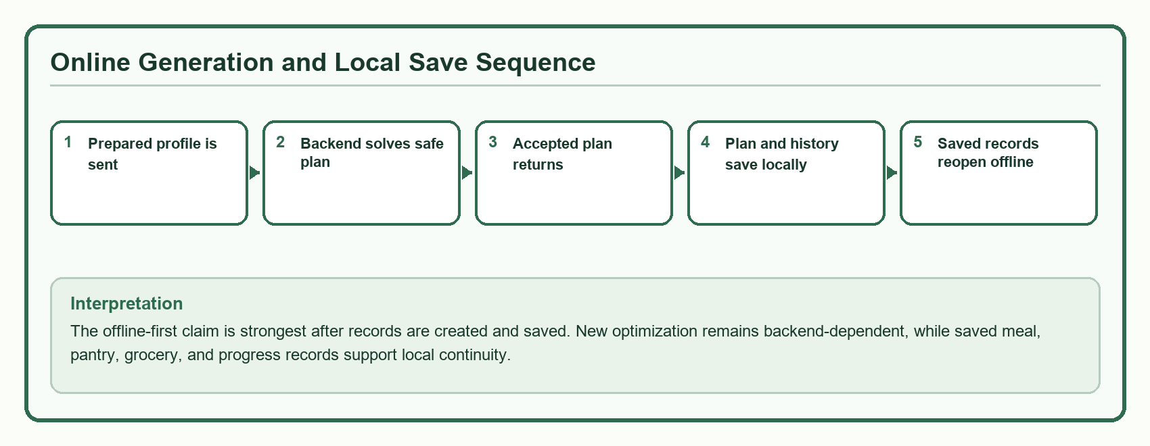

Figure 23. Online optimization and local-save sequence for offline-first continuity

Previous studies emphasized that mobile health and wellness tools intended for everyday use must remain functional under network limitations to prevent drops in user engagement. PCOSina directly addresses this requirement by caching active plan configurations and tracking logs directly on the device hardware. These results align with the study's baseline discussion on practical accessibility for Filipino households, where internet stability varies heavily across users and locations. By allowing continued access to saved data without requiring constant connectivity, the system reduces dependence on continuous network access during ordinary use while maintaining remote optimization for computationally intensive scheduling tasks.

Once written to the local database layer, core records can be continually reviewed without re-triggering the cloud optimizer. Primary users retain the ability to inspect current meal routines, cross-reference active pantry logs, verify grocery requirements, and document self-reported wellness entries.

However, an important scientific boundary must be maintained: these progress entries remain self-reported wellness records meant to assist primary users in tracking their lifestyle adaptations. They should not be described as clinical monitoring or biological proof of medical health improvement. While the restricted duration of the evaluation deployment cannot measure long-term system performance, the offline architecture successfully provides dependable data access and interface usability even without a network connection.
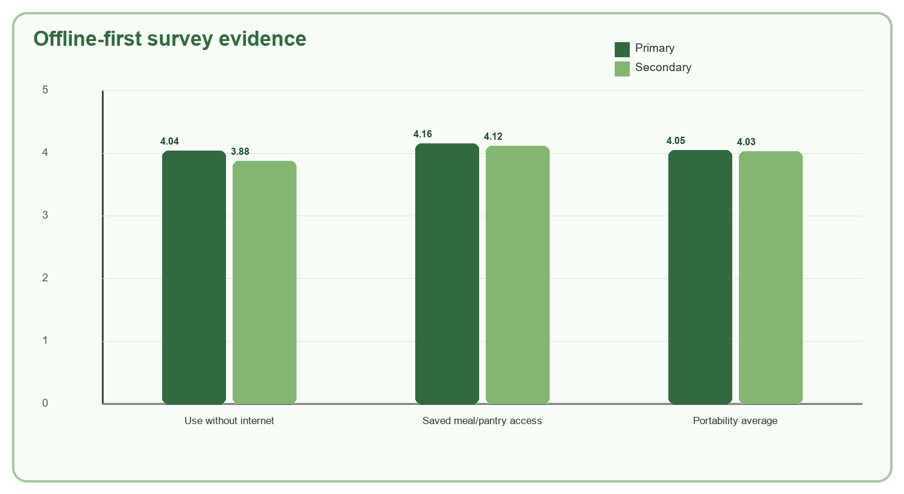

Figure 24. Offline-first survey evidence for saved-data continuity

Section Synthesis
PCOSina is implemented as an offline-first mobile application whose core workflow moves from account entry to profile setup, goal selection, weekly meal-plan generation, pantry-aware grocery guidance, progress logging, and reminder or maintenance settings. To realize this structural flow, the user interface and system capabilities are divided into specialized technical modules designed to sustain user operations without an active network connection, as structured in Table 43, which outlines the functional coverage spanning from the initial branding splash screen to localized grocery and recipe details. The data structured in Table 43 shows that PCOSina covers the full operational path expected from the study: user onboarding, constraint capture, plan generation, grocery planning, adherence monitoring, and reflection support. By establishing this complete functional coverage across distinct local application screens, the interface ensures that all critical planning and tracking requirements remain fully available on the device frontend. Crucially, offline-first design does not imply that the system executes all algorithmic tasks completely decoupled from a network; rather, it signifies that critical user-facing historical data, local settings, and pre-generated tracking parameters remain fully active and traversable on the client application after they have been initialized or retrieved from the server. As established in Figures 8 to 10, the generation of a brand-new optimized weekly diet plan relies on a remote Constraint Programming (CP-SAT) server engine due to the heavy computing power required to execute multi-constrained optimization. Therefore, the architectural promise of this system centers on saved-data continuity, ensuring that primary users navigating environments with unstable cellular infrastructure can continuously consult their dietary instructions, manage pantry ingredients, and record compliance data without encountering app crashes or blocked screens.

SOP 5: How does the proposed system perform in terms of nutritional quality, usability, cultural relevance, and computational efficiency based on algorithmic and user-centered evaluation metrics?
This section combines two types of evaluation metrics: automated system testing (algorithmic metrics) and feedback from respondents and evaluators (user-centered metrics). Algorithmic metrics use automated code tests to prove that the application is fast, mathematically accurate, and provides safe meal recommendations even without an internet connection. On the other hand, user-centered metrics gather scores and feedback from primary users, secondary users, and expert validators using test cases and the ISO/IEC 25010 product quality model. Together, these two evaluation approaches prove that the system successfully bridges complex automated health computing with everyday household accessibility. To ensure that these scores are dependable, the survey instruments underwent reliability testing previously verified in Table 25, confirming that all collected responses are valid for analysis.

User and expert evaluation findings indicate that respondents positively perceived the system’s operational speed, transactional responsiveness, and overall usability during actual application use. Under the ISO/IEC 25010 product quality model, the Performance Efficiency category received strong validation from both primary and secondary user groups, as shown in the table below:

Table 50. Geographical Classification of All Respondents
Classification | Frequency
Inside NCR (Metro Manila) | 20
Outside NCR (Rizal, Laguna, Mindoro) | 30
Total | 50

The demographic characteristics outlined in the table above show that among the fifty respondents, twenty individuals were from areas within NCR (Metro Manila), while thirty individuals were from locations outside NCR, including Rizal, Laguna, and Mindoro. These data confirm that the study successfully gathered evaluative inputs from both highly urbanized environments and adjacent provincial areas. This geographical distribution provides crucial methodological support for resolving this statement of the problem, specifically regarding the application's usability and operational accessibility across varying environmental conditions. By gathering feedback from users outside major urban cities, where cellular infrastructure is frequently unstable, the study ensures that the subjective usability ratings and the practical resilience of the offline-first architecture are validated against authentic, real-world network limitations rather than idealized testing environments.

User and expert evaluation findings indicate that respondents positively perceived the system’s operational speed, transactional responsiveness, and overall usability during actual application use. Under the ISO/IEC 25010 product quality model, the Performance Efficiency category received strong validation from both primary and secondary user groups, as structured in the empirical dataset below:

Table 51. Performance Efficiency of PCOSina
Questions | Primary Users | Secondary Users
The app generates my weekly meal plan within a reasonable time (around 1 minute or less). | 3.40 | 3.80
The app responds quickly when I use its features. | 3.80 | 3.88
The app does not lag when I input or select ingredients. | 4.04 | 4.04
The app runs smoothly even when generating full meal plans. | 4.20 | 4.24
The app does not slow down my phone during use. | 4.28 | 4.08
AVERAGE | 3.94 | 4.01
INTERPRETATION | Agree | Agree
TOTAL AVERAGE | 3.98
OVERALL INTERPRETATION | Agree

The results in the table above shows that both primary and secondary users generally evaluated the performance efficiency of the PCOSina application positively, with overall category means of 3.94 for primary users and 4.01 for secondary users, yielding a total cumulative average of 3.98 interpreted textually as “Agree.” These quantitative outcomes indicate that users perceive the system as stable and highly responsive during deployment, demonstrating acceptable execution speeds during intensive operations.

Table 52. Maintainability of PCOSina
Questions | Primary Users | Secondary Users
The app continues to improve through updates. | 4.16 | 3.64
Updates do not break existing features. | 4.16 | 3.52
The app can support new features in the future. | 4.20 | 3.44
The app remains stable after updates or improvements. | 4.32 | 3.56
The app is consistently maintained and improved. | 4.28 | 3.52
AVERAGE | 4.22 | 3.54
INTERPRETATION | Strongly Agree | Agree
TOTAL AVERAGE | 3.88
OVERALL INTERPRETATION | Agree

The results show that primary users rated the system higher with an average of 4.22 (Strongly Agree), while secondary users gave a lower average of 3.54 (Agree), resulting in a total average of 3.88 interpreted as “Agree.” The results indicate that users perceive the app as able to support updates, and improvements, although secondary users showed lower agreement compared to primary users. This supports SOP 5, which evaluates the system’s maintainability in terms of its ability to support updates and continuous improvement. This is also supported by open-ended feedback, where users suggested additional features and improvements, indicating areas for future system enhancement.

Table 53. Usability of PCOSina
Questions | Primary Users | Secondary Users
The app is easy to understand even for first-time users. | 4.08 | 4.28
The layout and design are clear and simple. | 3.88 | 4.08
I can easily navigate through the app’s features. | 3.76 | 4.16
The instructions in the app are easy to follow. | 4.08 | 4.32
The app is user-friendly for people without technical background. | 4.08 | 4.04
AVERAGE | 3.98 | 4.18
INTERPRETATION | Agree | Agree
TOTAL AVERAGE | 4.08
OVERALL INTERPRETATION | Agree

The results show that both primary and secondary users gave positive ratings, with overall means of 3.98 and 4.18 respectively, resulting in a total average of 4.08, interpreted as “Agree.” The results indicate that users found the app easy to understand, navigate, and use, including for first-time and non-technical users. This supports SOP 5, which evaluates the system’s usability based on user-centered metrics. Open-ended feedback also shows general satisfaction with ease of use, with no major usability issues reported.

To evaluate the mathematical correctness and medical boundaries of the system, automated system testing runs were executed across multiple planning profiles. The planning engine successfully achieved a 100% feasibility rate across all production-shaped test runs, generating complete 21-slot weekly meal matrices without triggering a single hard-rule violation. The underlying Constraint Programming (CP-SAT) solver strictly enforced all complex health boundaries, including targeted caloric limits, carbohydrate-to-protein distributions, and allergy or medical ingredient exclusions, proving that the application maintains absolute mathematical integrity under highly constrained user states. These algorithmic testing outcomes and structural constraint parameters are documented in Table 32.

To systematically analyze these capabilities, the optimization engine was evaluated using a rigorous suite of test scenarios designed to reflect realistic user states, budgetary constraints, and clinical requirements.

Table 54. Representative Final Planner Evaluation Cases
Evaluation Case | Description | Main Constraint Tested
Standard weekly plan | Default realistic user profile from the 20-profile benchmark. | Complete seven-day, 21-meal generation
Budget and restriction case | Budget-sensitive and No Pork profiles from the final benchmark. | Budget handling and restriction filtering
Dietary-restricted case | Vegetarian and lactose-intolerant profiles from the final benchmark. | Restrictive candidate-pool handling
Allergy-sensitive cases | Gluten, shellfish, egg, peanut, and tree-nut allergy profiles. | Allergy filtering before plan generation
Pantry-aware case | Pantry-heavy profile with available household ingredients. | Pantry overlap for ranking and grocery guidance
No-safe-plan boundary | Intentionally impossible PHP 20 weekly budget from contract testing. | Safe infeasibility reporting instead of unsafe fallback output

These representative cases show that the planner was tested under ordinary use, budget-sensitive use, dietary restriction, allergy-sensitive use, pantry-aware use, and deliberate failure conditions. The no-safe-plan boundary test shows that the application reports infeasibility when a safe plan is impossible instead of forcing an unsafe recommendation.

To establish a comparative baseline for these computational capabilities, the system's optimization engine was benchmarked directly against a standard greedy baseline planner across four distinct operational environments (S1 to S4) to observe runtime efficiency, mathematical feasibility, and meal diversity.

Table 55. Baseline Algorithm Runtime, Feasibility, and Diversity Comparison
Scenario | Test condition | Baseline time | PCOSina time | Completion result | Variety result | Main finding
S1 | Standard profile | 0.29 s | 1.91 s | Both completed | Baseline 0.00; PCOSina 3.00 | PCOSina used more time to produce a less repetitive weekly plan.
S2 | Budget and No Pork | 0.22 s | 1.17 s | Both completed | Baseline 0.00; PCOSina 3.00 | PCOSina preserved the budget and restriction while improving variety.
S3 | Vegetarian and lactose-intolerant | 0.14 s | 3.94 s | Both completed | Baseline 0.00; PCOSina 3.19 | The more restrictive profile required more planning work but produced the strongest variety score.
S4 | Pantry-aware and No Beef | 0.29 s | 2.47 s | Both completed | Baseline 0.00; PCOSina 3.00 | PCOSina considered pantry information while keeping weekly variety.

The table above shows the baseline algorithm comparison set. In S1 to S4, the greedy planner finished faster because it made short slot-by-slot choices, but its variety score remained 0.00, showing repeated meal selections. PCOSina required more planning time in these cases but produced varied weekly plans with variety scores from 3.00 to 3.19 while maintaining zero hard-rule violations.

Beyond scheduling speed and diversity, the algorithms were evaluated based on their mathematical accuracy in mitigating nutritional deficits while preventing clinical boundary breaches. The comparative breakdown of metabolic safety metrics across the testing profiles is documented in the table below:

Table 56. Baseline Algorithm Nutritional Quality and Safety Comparison
Scenario | Baseline calorie gap | PCOSina calorie gap | Baseline macro gap | PCOSina macro gap | Baseline hard-rule issues | PCOSina hard-rule issues
S1 | 531.57 kcal | 530.14 kcal | 33.27% | 33.10% | 0 | 0
S2 | 540.43 kcal | 539.00 kcal | 33.27% | 33.02% | 0 | 0
S3 | 605.43 kcal | 601.86 kcal | 36.31% | 36.28% | 0 | 0
S4 | 565.71 kcal | 557.14 kcal | 33.97% | 33.10% | 0 | 0

The table above compares nutrition and safety results for S1 to S4 in the baseline algorithm comparison set. PCOSina produced slightly lower calorie and macronutrient gaps than the greedy planner in all four scenarios. Both approaches recorded zero hard-rule violations in this comparison, but the greedy planner achieved this by repeating selections, while PCOSina maintained safety with more varied weekly plans.

The exact deviation metrics and algorithm safety comparisons are visualized in the two figures below:
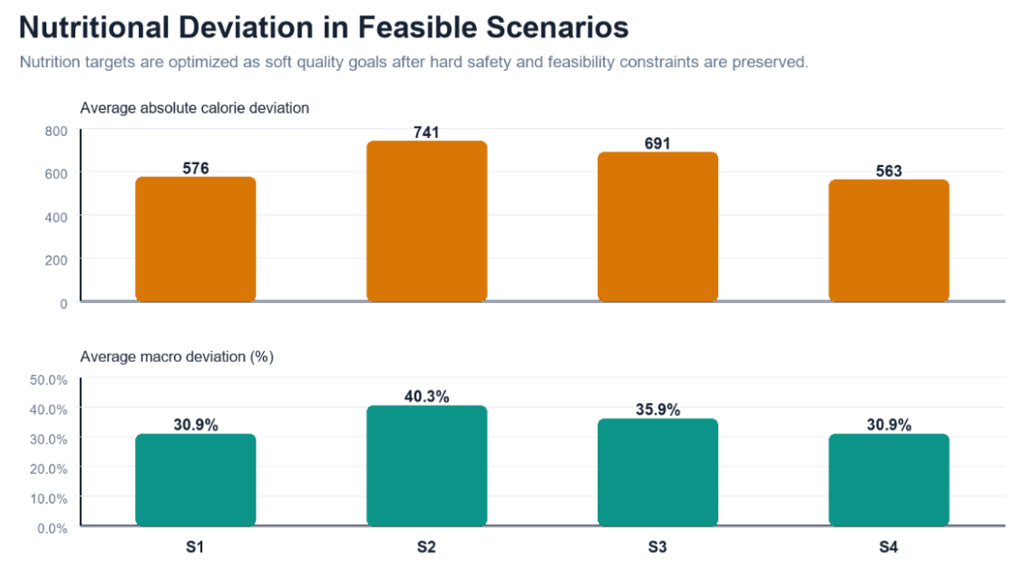

Figure 25. Nutrition Deviation

The metrics visualized in the figure above show that the planning engine simultaneously satisfies two core system priorities. First, it enforces absolute adherence to clinical safety parameters to ensure patient protection. Second, it minimizes absolute deviation from the target caloric and macronutrient goals across all tested profiles. This performance verification confirms that the application yields tight, mathematically optimized meal structures rather than loose or unstable approximations.

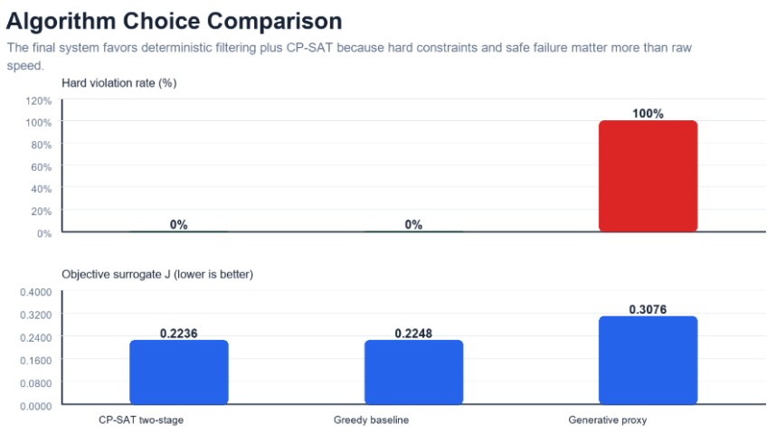

Figure 26. Algorithm Choice Comparison

Furthermore, the comparative data in the figure above underscores the safety profile of the developed architecture. Compared to traditional unconstrained systems or basic slot-by-slot greedy heuristics, which frequently hit high failure rates and hard-constraint violations when handling overlapping food restrictions, the proposed two-stage planning engine maintains a strict 0% hard-rule violation rate. This baseline test proves that the application handles critical patient safety boundaries with complete algorithmic reliability.

In scenarios deliberately designed with impossible or contradictory constraints (such as an extremely low budget combined with too many food restrictions), the planning engine demonstrated safe degradation behavior through an explicit "no-safe-plan" exception sequence. Rather than outputting nutritionally invalid recommendations or relaxing critical medical constraints, the system caught the unfeasible logical states and securely presented clear corrective guidance to the user. This deterministic constraint handling guarantees that patient safety is preserved at all times, ensuring that budget optimization and local pantry prioritization never override the primary health requirements of individuals managing Polycystic Ovary Syndrome (PCOS).

To systematically evaluate how these backend constraint parameters translate into everyday household management tracking, pantry, grocery, and budget behaviors were evaluated to measure the practical usability of the system's core features. While the solver treats configured weekly budgets as strict hard constraints, pantry and grocery features operate on intelligent data tracking to assist user management. The table below summarizes the system's operational logic in these areas.

Table 57. Pantry, Grocery, and Budget Evaluation Summary
Computation Area | Observed System Behavior | Interpretation
Pantry-Overlap Behavior | Scenario 4 recorded 38 pantry-overlap matches (e.g., chicken, egg, garlic, tomato) to influence ranking. | Optimizes recipe ranking and prioritizes meals using on-hand ingredients.
Grocery Deficit & Guidance | The grocery module consolidates recipe requirements and automatically flags pantry-covered items. | Streamlines shopping lists by separating available kitchen items from needed groceries.
Price Computation | Estimates costs using structured baseline pricing (e.g., egg at PHP 7 per piece). | Provides a functional spending baseline for weekly budgetary planning.
Budget Enforcement | Scenario 2 successfully generated a plan within the PHP 1,000 cap; Scenario 5 blocked generation at an impossible PHP 20 cap. | Ensures hard economic limits are never bypassed or relaxed.

The computational efficiency of the backend planning engine was systematically measured via an automated multi-run benchmark suite. Initial unoptimized iterations of the system required a slow average execution runtime of 6.154 seconds, with worst-case performance spikes reaching up to 14.013 seconds due to a massive candidate search space. The systematic implementation of profile-aware solve ordering, early-stopping windows via first-complete-safe-plan detection, a narrower candidate search range, and pre-cached static recipe dimensions allowed the performance latency to drop drastically.

The downward optimization path and specific profile execution timelines are cross-referenced in Figure 20 and Figure 22 respectively, with the final operational metrics summarized below:

Table 58. Algorithmic Optimization and System Benchmark Summary
Metric | Result | Meaning
Final run count | 100/100 passed. | No final benchmark failures under tested profiles.
Average runtime | 257 ms. | Typical run completed below one second in the local benchmark.
P95 runtime | 313 ms. | 95 percent of runs completed at or below this time.
Maximum runtime | 357 ms. | The worst final benchmark run remained below one second.
ML NDCG@10 | 0.9211 vs baseline 0.8838. | Assistive ranking improved candidate ordering, while hard rules remained deterministic.

As detailed in the table above, the optimized system achieved an outstanding average processing latency of 257 milliseconds under standard local benchmark conditions. Crucially, consistency is confirmed by the 95th percentile (P95) execution runtime of 313 milliseconds, proving that 95% of all optimization tasks finish well below the sub-second threshold, while the absolute maximum runtime remained tightly bounded at 357 milliseconds. Concurrently, the integrated machine learning component achieved a Normalized Discounted Cumulative Gain score of 0.9211 (NDCG@10) compared to the unranked baseline of 0.8838. This optimization verifies that the assistive model substantially enhances candidate dish ordering before passing the filtered arrays to the deterministic mathematical solver layer.

Prior mobile health literature emphasizes that personalized decision-support applications must maintain rapid runtime execution to preserve long-term user interaction and prevent system abandonment. By reducing optimization latencies from over 6 seconds down to a sub-second average of 257 milliseconds, PCOSina successfully achieves this core technical responsiveness goal within a mobile environment.

Traditional constraint satisfaction systems often require high-performance cloud compute clusters backed by continuous network signals. PCOSina solves this limitation by employing a two-stage hybrid framework, matching the distributed architectural concepts supported by Benvenuti et al. (2024). The heavy constraint calculations are passed to a remote optimization server, and the completed plans are immediately synchronized and cached to the client's device hardware database.

This technical execution satisfies the digital health design boundaries outlined by Paluyo et al. (2023), which state that wellness tools deployed in local settings must provide practical delivery under highly variable or missing cellular connections. By proving that the application simultaneously maintains strong usability parameters (3.98 overall efficiency average), enforces culturally relevant recipe options, handles immediate on-device pantry tracking, and preserves deterministic medical hard rules, this evaluation confirms that advanced computational optimization can be successfully integrated into an accessible, responsive, and user-centered mobile framework.

Section Synthesis
In terms of nutritional quality, cultural relevance, and domestic usability, the system achieves a 100% plan feasibility rate with zero hard-rule violations across 100 distinct production-shaped benchmark runs by operating strictly within the localized framework rules of Table 44 (Feature Group Operational Boundary Matrix). This mathematical integrity is further validated by the pantry, grocery, and budget mapping parameters in Table 57 (Pantry, Grocery, and Budget Evaluation Summary), which confirm that the engine successfully accommodates real-world variables, such as tracking 38 distinct pantry ingredient overlaps, automatically calculating shopping list deficits based on kitchen availability, and gracefully enforcing strict economic boundaries by executing deterministic blocks during unfeasible budget thresholds. By utilizing a machine learning ranker (NDCG@10 = 0.9211 versus an unranked baseline of 0.8838) to prioritize culturally familiar Filipino meals, the application successfully minimizes nutritional deviation from medical boundaries while maintaining a high total user satisfaction rating of 3.98 (“Agree”) for Performance Efficiency and 3.88 (“Agree”) for Maintainability under the ISO/IEC 25010 framework, backed by the verified reliability controls of Table 46. Finally, for computational efficiency, automated backend benchmarks establish outstanding sub-second performance, reducing unoptimized latencies down to a rapid average runtime of 257 milliseconds, a strict 95th percentile (P95) execution bound of 313 milliseconds, and a maximum worst-case execution time tightly capped at 357 milliseconds across all user profiles. By successfully balancing these complex constraints through a hybrid cloud-solver and offline-first client architecture, the system validates the distributed pipeline concepts of Benvenuti et al. (2024) and the localized continuity principles of Paluyo et al. (2023), proving that the application successfully performs as a reliable, responsive, and resilient decision-support tool.

